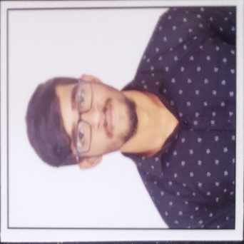**Resume**

**Name** - S Sudharshan

**Mobile** **no** - 8431613550

**Gmail** – ysudharshan8@gmail.com

**LINKEDIN ID** - https://www.linkedin.com/in/sudharshan-yadav-38b008222

**Career Objective** - Secure a responsible career opportunity to fully utilize my training and skills, while making a significant contribution to the success of the company.

**Education Qualification**

|  |  |  |  |
| --- | --- | --- | --- |
| **Year** | **Degree/Course** | **Institution** | **Percentage** |
| 2021 | B.com | Seshadripuram college | 60% |
| 2017 | 2nd PUC | Seshadripuram college | 70% |
| 2015 | SSLC | St.lourdes high school | 57% |

**Key Skill**

* Good communication skills
* Team worker
* Patience
* Ability to work under pressure

**COUSES AND CERTIFICATIONS**

* LINUX
* AMAZON WEB SERVICE
* DEVOPS